
Mid Exam Report
Distributed and Parallel System
Created by:
Tengku Mahesa Omar Falah (001202300121)
Putra Amalul Kamal (001202300221)

1. Project Overview

Application Description
Task Manager Pro is a full-stack web application that allows users to manage their daily tasks efficiently. The application consists of:
- Frontend: React.js application with modern UI/UX
- Backend: Node.js Express API with RESTful endpoints
- Database: MongoDB for data persistence
- Containerization: Docker and Docker Compose for deployment

Key Features
- ✅ Add new tasks
- ✅ Mark tasks as complete/incomplete
- ✅ Delete tasks
- ✅ Filter tasks (All, Active, Completed)
- ✅ Real-time task statistics
- ✅ Responsive design
- ✅ Health check endpoints

2. Technology Stack

Frontend
- Framework: React.js 18.2.0
- Build Tool: Vite 4.4.5
- HTTP Client: Axios 1.6.0
- Styling: Custom CSS with modern design

Backend
- Runtime: Node.js 18
- Framework: Express.js 4.18.2
- Database: MongoDB with Mongoose ODM
- Additional: CORS, dotenv for environment variables

Containerization
- Container Platform: Docker
- Orchestration: Docker Compose
- Base Images: Node.js 18 Alpine, MongoDB 7.0
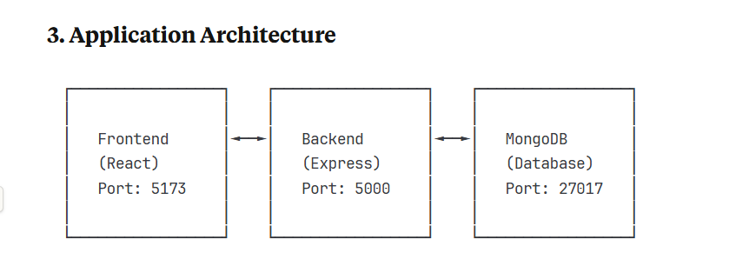
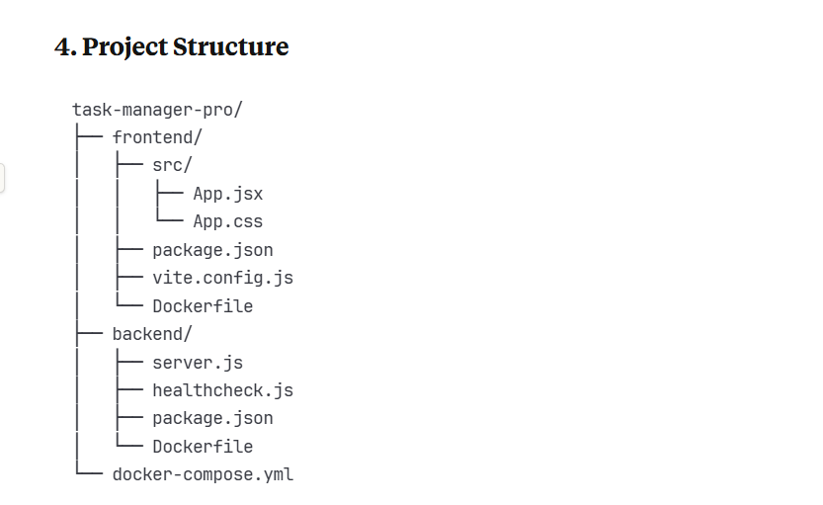

5. Docker Implementation

Frontend Dockerfile
The frontend Dockerfile uses Node.js 18 Alpine image for lightweight deployment:
- Installs dependencies using npm
- Exposes port 5173
- Runs Vite development server with host configuration

Backend Dockerfile
The backend Dockerfile includes security best practices:
- Uses Node.js 18 Alpine base image
- Creates non-root user for security
- Implements health check using custom script
- Exposes port 5000

Docker Compose Configuration
The docker-compose.yml orchestrates three services:
- MongoDB: Database service with health check
- Backend: API service dependent on MongoDB
- Frontend: React app dependent on Backend

6. Step-by-Step Deployment Guide

Prerequisites
- Docker installed on your system
- Docker Compose installed
- Git for version control

Step 1: Clone/Setup Project Structure
bash
# Create project directory
mkdir task-manager-pro
cd task-manager-pro

# Create subdirectories
mkdir frontend backend

Step 2: Setup Frontend
bash
cd frontend
# Create all frontend files (App.jsx, App.css, package.json, etc.)
# Create Dockerfile

Step 3: Setup Backend
bash
cd ../backend
# Create all backend files (server.js, package.json, etc.)
# Create Dockerfile

Step 4: Create Docker Compose
bash
cd ..
# Create docker-compose.yml in root directory

Step 5: Build and Deploy
bash
# Build and start all services
docker-compose up --build

# Run in detached mode
docker-compose up -d --build

Step 6: Verify Deployment
bash
# Check running containers
docker-compose ps

# View logs
docker-compose logs

# Test endpoints
curl http://localhost:5000/api/health

7. Screenshots

Application Interface

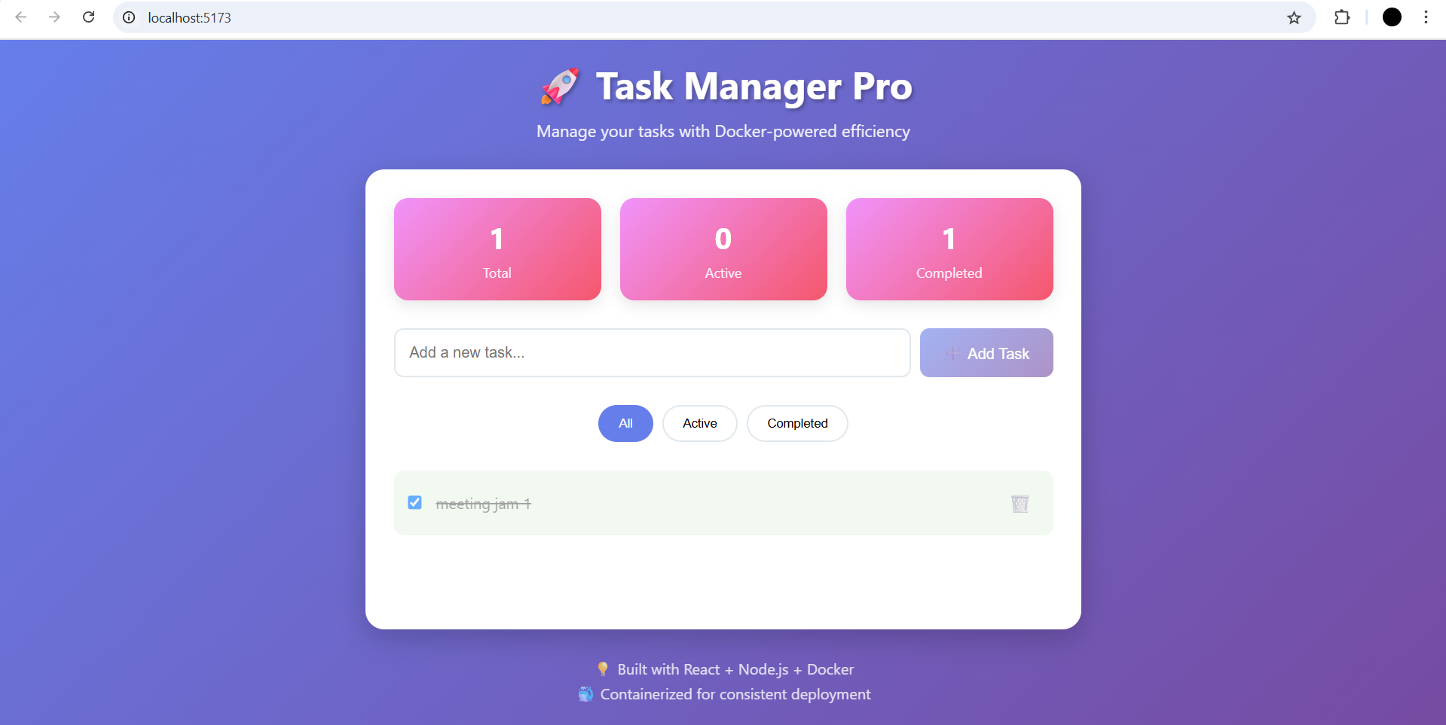
Main application interface showing task management features

API Health Check
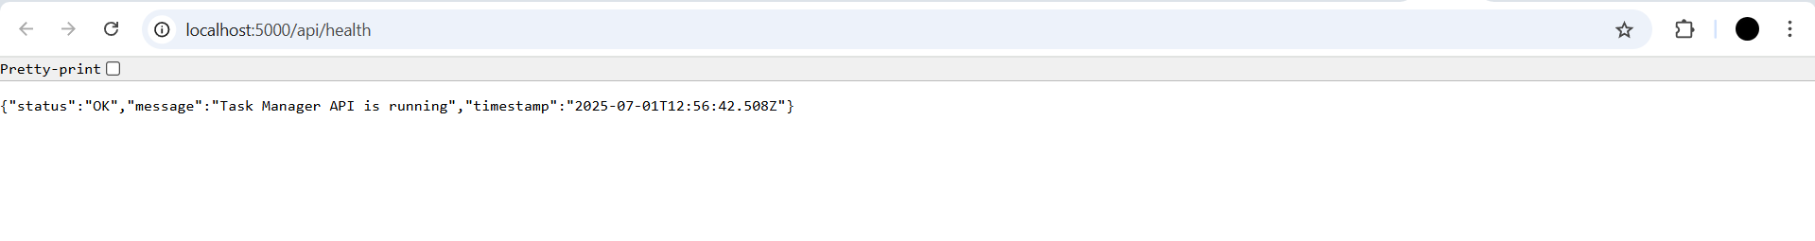
Backend API health check endpoint response

Docker Containers
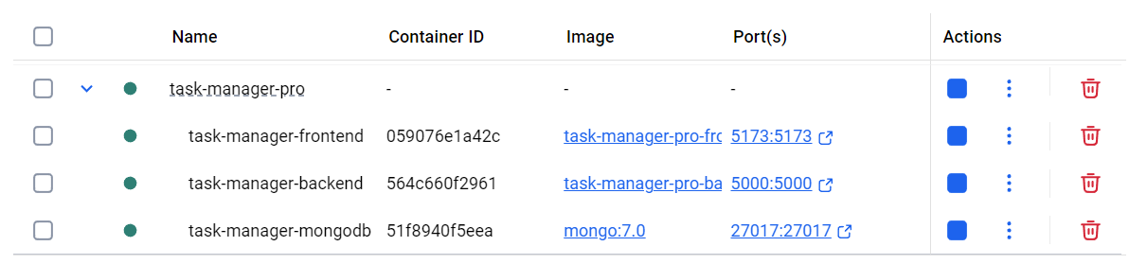
Docker containers running successfully

8. Docker Commands Reference

Basic Commands
bash
# Build and start services
docker-compose up --build

# Stop services
docker-compose down

# View running containers
docker-compose ps

# View logs
docker-compose logs [service-name]

# Execute commands in container
docker-compose exec [service-name] [command]

Development Commands
bash
# Rebuild specific service
docker-compose build [service-name]

# Scale services
docker-compose up --scale [service-name]=3

# Remove volumes
docker-compose down -v

9. Environment Configuration

Frontend Environment Variables
env
VITE_API_URL=http://localhost:5000/api

Backend Environment Variables
env
PORT=5000
MONGODB_URI=mongodb://mongodb:27017/taskmanager
NODE_ENV=development

10. Testing the Application

Functional Testing Steps
- Access Frontend: Navigate to http://localhost:5173
- Add Task: Enter task title and click "Add Task"
- Mark Complete: Click checkbox to toggle completion
- Filter Tasks: Use filter buttons (All, Active, Completed)
- Delete Task: Click delete button to remove task
- API Testing: Access http://localhost:5000/api/health

Expected Results
- Frontend displays modern task management interface
- Tasks can be added, completed, and deleted
- Statistics update in real-time
- API returns JSON responses
- All containers run without errors

11. Network Configuration

Docker Network
- Network Name: task-manager-network
- Driver: bridge
- Services Communication: Internal DNS resolution

Port Mapping
- Frontend: Host 5173 → Container 5173
- Backend: Host 5000 → Container 5000
- MongoDB: Host 27017 → Container 27017

12. Volume Management

Persistent Data
- MongoDB Data: Persistent volume for database
- Development Volumes: Hot reload for code changes

13. Security Considerations

Backend Security
- Non-root user execution
- Input validation and sanitization
- CORS configuration
- Error handling middleware

Container Security
- Alpine Linux base images (smaller attack surface)
- Health checks for service monitoring
- Resource limitations through Docker Compose

14. Monitoring and Health Checks

Health Check Implementation
- Backend health check endpoint: /api/health
- MongoDB health check using mongosh
- Docker health check configuration
- Service dependency management

15. Troubleshooting Guide

Common Issues
- Port conflicts: Change port mappings in docker-compose.yml
- MongoDB connection: Ensure MongoDB service is healthy
- CORS errors: Verify backend CORS configuration
- Build failures: Check Dockerfile syntax and dependencies

Debug Commands
bash
# Check container logs
docker-compose logs [service-name]

# Interactive shell
docker-compose exec [service-name] /bin/sh

# Inspect networks
docker network ls
docker network inspect task-manager-pro_task-manager-network

16. Conclusion
Task Manager Pro successfully demonstrates:
- Containerization: All services running in Docker containers
- Service Orchestration: Docker Compose managing multi-container application
- Modern Architecture: Separation of concerns with frontend, backend, and database
- Development Workflow: Hot reload and development-friendly configuration
- Production Ready: Health checks, security, and monitoring
The application showcases practical implementation of distributed systems concepts using Docker, providing a scalable and maintainable solution for task management.

